Connection error guidelines

1. First check sql server browser is running or not.

* For that right click on **my computer(THIS-PC) -> manage ->services and applications->Sql Configuration manager -> Sql server services**
* Make sure it is running. If it is not running then right click on start mode and change to start or go to properties and make it automatic and change to start.

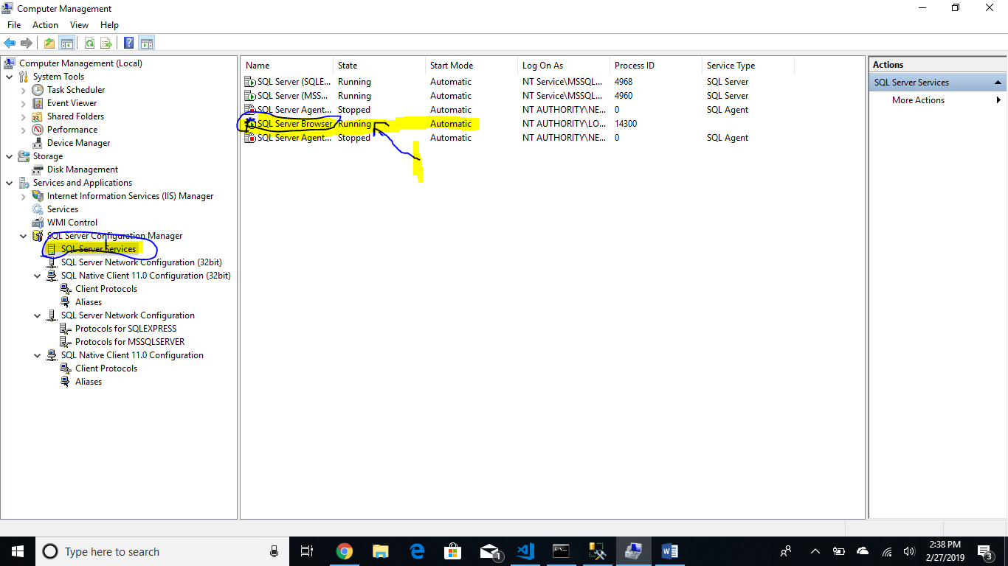

1. Then go to the **Sql server Network configuration** and **enable tcp/Ip service.** Like following image

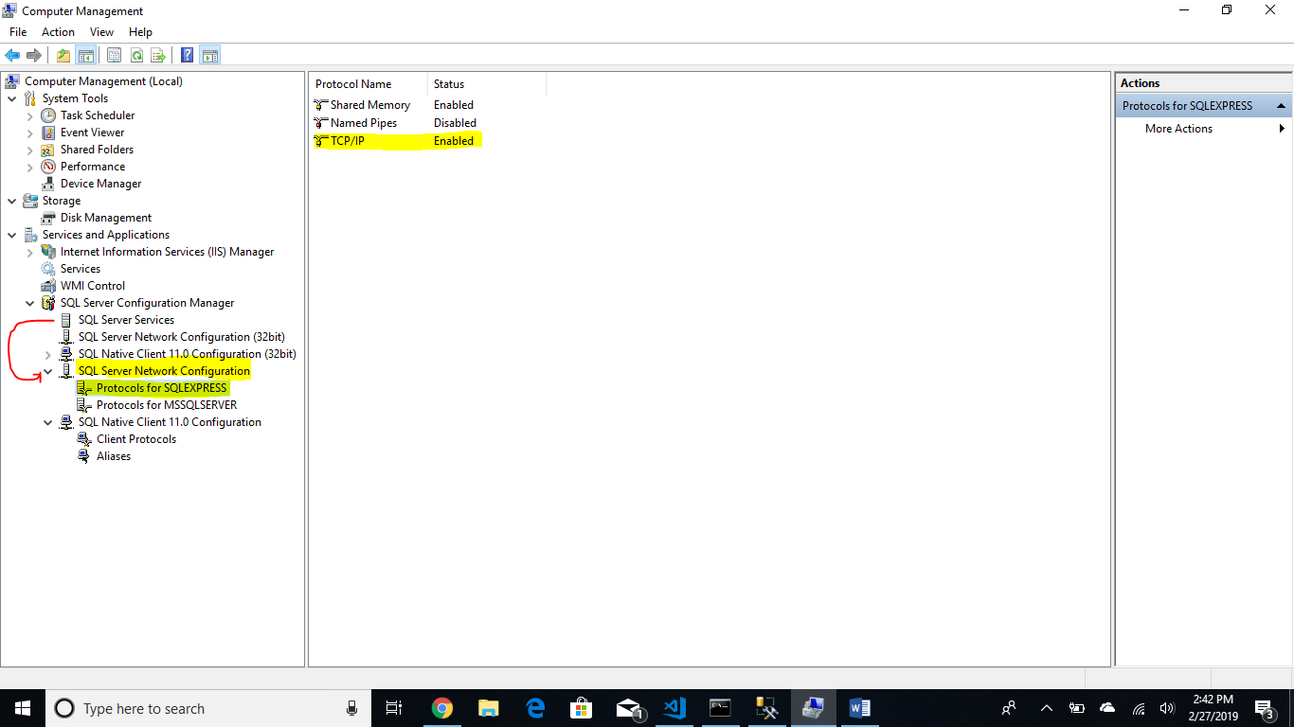

1. Still getting error for connection port is undefined then right click on **tcp/Ip** and goto **properties**. And select **IP addresses** tab scroll all the way down.

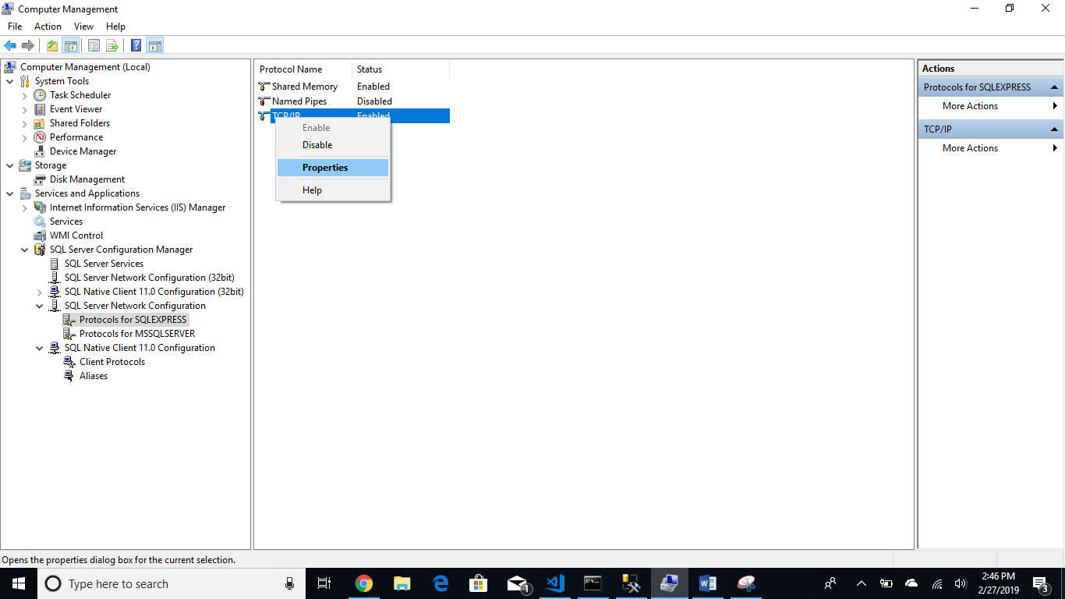

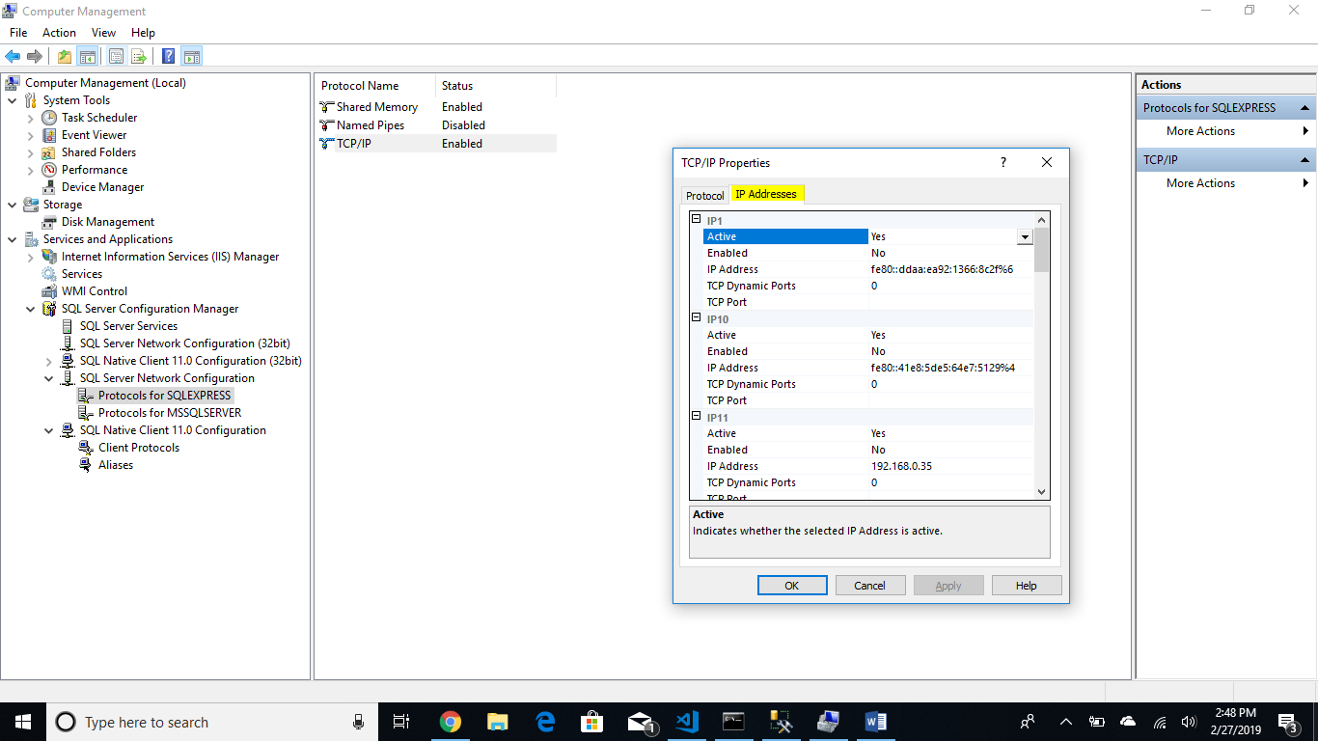

1. Set the IP ALL ports like this following image

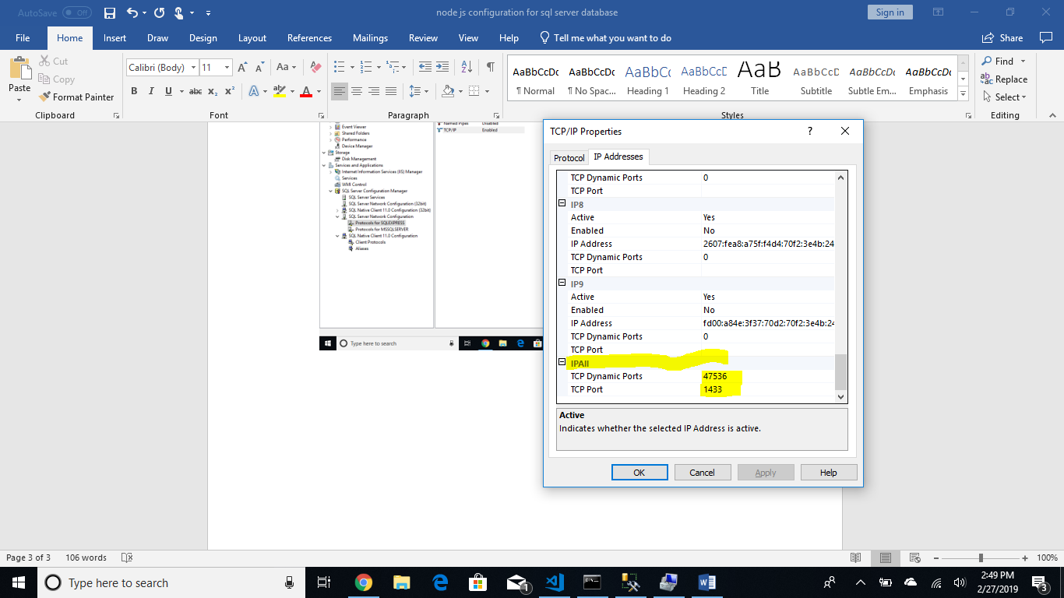

1. Then restart the sql server browser service then try it.